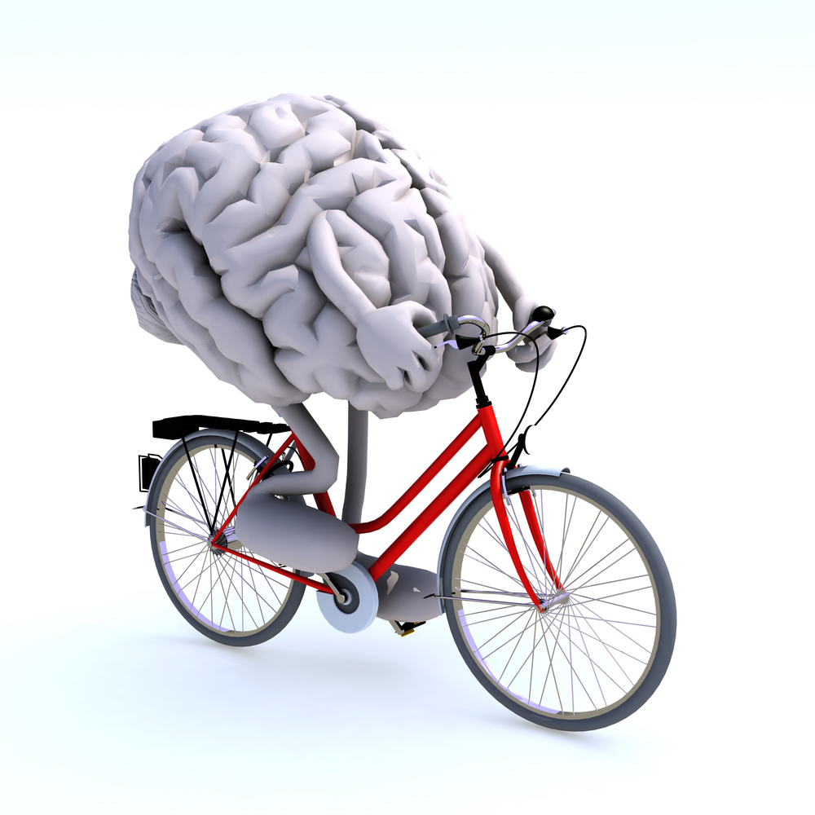
Sub Threshold Exercise Concussion Evaluation

Carleton Sport Medicine and Physiotherapy has been running a pilot program for the past year on athlete sub threshold exercise evaluation and implementing an at home exercise program. The feedback regarding the program has been very positive. The design of the program is based on a research paper (Leddy et al. 2012). The Carleton Sport Medicine and Physiotherapy research design objective is twofold: 1) to add to the existing database and publish our findings in an effort to help athlete’s recovery process from concussions. 2) Provide more information to Health Providers to assist in educating athletes in the role of exercise of the concussed athlete.

The referral criteria for sub threshold exercise testing is:
- Athletic individual actively participating in a sport 2 times/week at minimum with the goal of returning to activity.
- Athlete has been assessed by a Sport Medicine Physician/Concussion Specialist
- Athlete is between the ages of 18 and 55
- Athlete has suffered a concussion at least 6 weeks prior to study involvement
- Athlete must have access to a stationary bike for regular use during the study

The Carleton Sport Medicine and Physiotherapy has added a sub threshold exercise test in the clinic for athletes to continue to collect data for this pilot study. The testing takes approximately an hour. Scheduling can be arranged at 613-520-3511. The fee for the evaluation is $60.00

